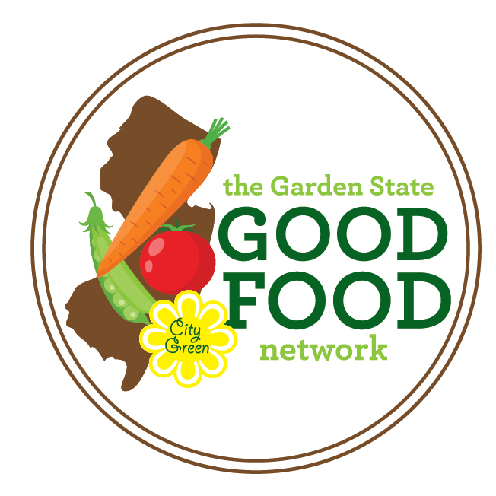
Garden State Good Food Network
Data Collection Overview

Below is an overview of the data collection process and requirements. You will be allowed to collect data in whatever format you see fit for your market, but we encourage you to use the data collection forms provided to ensure you are collecting the required data points. You will be required to submit your data to City Green through an Excel Spreadsheet or Google Form so that we can compile network-wide data to show our impact!

- Throughout your market day, collect SNAP and Good Food Buck data using the data collection forms. The following data points are REQUIRED and must be recorded for each market.

STEP 1: Transaction Log – record each transaction at the market manager’s table, and then total your numbers at the end of the day.

- Market Name and Date

- The # of New SNAP Customers
- Total # of SNAP Transactions

- SNAP $ Dollars Distributed
- Good Food Buck Incentive Dollars $ Distributed

STEP 2: Vendor Reimbursement Log – record the total SNAP dollars and Good Food Bucks that vendors turn into the market manager at the end of each day.

- SNAP $ Dollars Redeemed by Vendors
- Good Food Buck Incentive Dollars $ Redeemed by Vendors

- Total # of Vendors selling SNAP-eligible foods
- Total # of Vendors selling fruits and vegetables
- Total # of Market Vendors

Outreach Activity Log – throughout the season, keep track of outreach expenses and activities associated with the Garden State Good Food Network and Good Food Bucks. This does not need to be done every market day, but rather as a running list that will be submitted at mid-season and end-of-season.

Optional Data Entry Forms:
Post Market Questions – Record any extra information from the market day, such as number of total market visitors, the weather, special events, donations, or more!

Vendor Payment Log – Use this to track your payments to vendors for the Good Food Bucks and SNAP dollars that they receive each day. This is a good way to ensure that the market and the vendors are on the same page about payments that have been received or are outstanding.

- Submit Data to City Green
All of the above data points must be submitted to City Green at the mid-season evaluation and end-of-season evaluation due dates. Date can be submitted either by filling out and emailing the Excel spreadsheet provided, or by submitting data online through the Google Form survey link provided. Please choose whichever method is most convenient for you! We recommend entering your data on a weekly basis so that your data entry doesn’t pile up!

Use this data sheet to record any SNAP and Good Food Buck transactions that occur. Please include your daily transaction and distribution totals on the second page. |  |  |  | Market Name:
 |  |  |  | Date:
# | Have you ever shopped at this farmers market before today?  (Yes or No) | SNAP Dollars ($) Distributed | Good Food Buck incentives Distributed (Match SNAP amount up to $10 or $20) | # | Have you ever shopped at this farmers market before today?  (Yes or No) | SNAP ($) Tokens Distributed |  | Good Food Buck incentives Distributed (Match SNAP amount up to $10)
Ex: | Yes | $10 | $10 | 16
1 |  |  |  | 17
2 |  |  |  | 18
3 |  |  |  | 19
4 |  |  |  | 20
5 |  |  |  | 21
6 |  |  |  | 22
7 |  |  |  | 23
8 |  |  |  | 24
9 |  |  |  | 25
10 |  |  |  | DAILY DISTRIBUTION TOTALS
11 |  |  |  |  |  |  | SNAP Tokens Distributed | Good Food Bucks Distributed
12
13 |  |  |  | Total Amount |  |  | $ | $
14 |  |  |  | Total # of Transactions |  |  | # | #
15 |  |  |  | Total # of New Customers |  |  | # | #
STEP 1: SNAP and Good Food Buck Transaction Log

STEP 2: Vendor Reimbursements

Use this log to record the amount of SNAP Tokens and Good Food Buck Incentives that Vendors turn into you at the end of each day. |  |  |  | MARKET NAME:
 |  |  |  | DATE:
# | Vendor Name |  |  | Sells Fresh Fruits and/or Vegetables? (Y/N) | SNAP Tokens Redeemed | Good Food Buck Incentives Redeemed
1
2
3
4
5
6
7
8
9
10
11
12
13
TOTAL # of SNAP Vendors: |  | TOTAL # of Produce Vendors: | TOTAL # of ALL Vendors: |  | TOTAL SNAP $ REDEEMED: | TOTAL GFB $  REDEEMED:

OPTIONAL: Post-Market Questions
Market Name: | Date:
How many people do you estimate came to your market today?

What was the average temperature today (°F)?

What was the weather like today? (circle all that apply) | Sunny Cloudy Rainy Windy Snowing Other:_______________
Were there any non-vendor groups (non-profits, schools, county or municipal programs, etc.) at the market today using a table or booth to share information, provide free goods or services, or conduct a survey? | No If Yes, please specify:
Did any vendors donate food to social services groups today? | No If Yes, please describe:
Did you do any additional marketing for today? | No If Yes, please describe
___ SNAP outreach
___ WIC outreach
___ Gardening demonstration
___ SNAP-Ed programs and activities
___ EFNEP nutrition education/activities
___ Other nutrition education (non-federally funded)
___ Live music ___ Chef/cooking demonstration
___ Taste test ___ Health fair
___ Activities for kids ___ Contest

____None Other:_____________________

Did you have any of the following activities today? Check all that apply:
Notes:

OPTIONAL: Use this log to manually record your vendor reimbursements every time you pay out a vendor.
Vendor Payment Log Market:
Market Date | Vendor Name | SNAP $ Redeemed | Good Food Bucks Redeemed | TOTAL  Reimbursed | Vendor Signature | Check # / Cash

